Genealogy research September 2020
Destination: Archdiocesan Archive in Pelplin,
Name: Grünberg

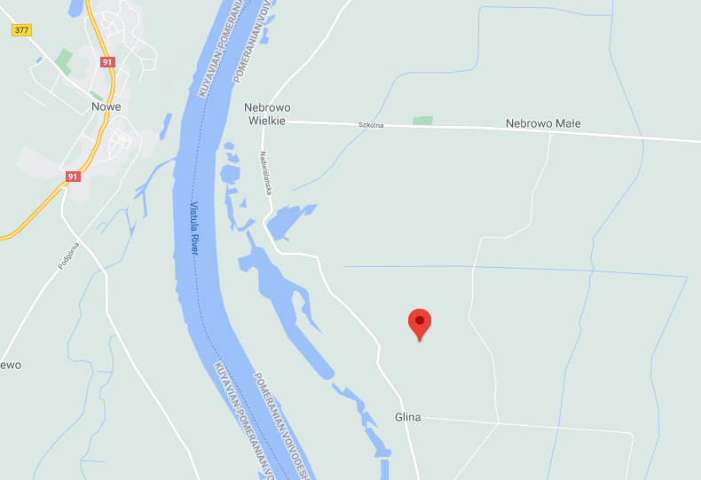

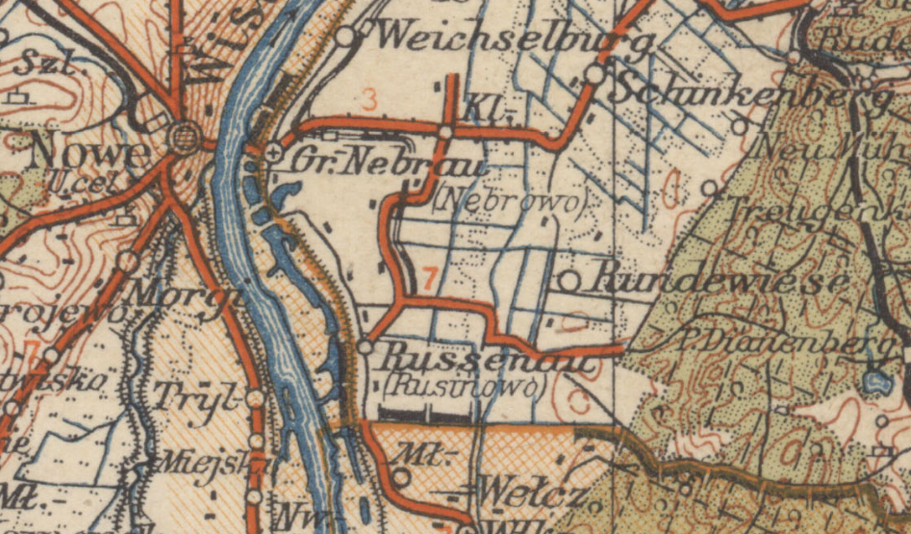

Based on your information about the Grünberg Family we knew that there was Carl Gruneberg – born possibly around 1848 or 1849 (March 9th), who was married to Teresa Kohlberg – born January 16th 1851, and they had the following children:
- Augusta Bartha born on March 21st 1879 in the area of Kwidzyń
- Frank Albert – born around 1874
- Anna – born around 1875
- Otto – born around 1884
- Emil – born around 1887
- Fred – born around 1889
The whole family emigrated to the USA in 1894.
The first record I was able to find was a marriage of Karl and Teresa.

The marriage took place in Nowe (German: Neuenburg) on November 11th, 1873, between:
- Carl Grünberg, aged 24, Stangendorf (Pol: Glina) resident, working as a skipper (German: Schiffer), and
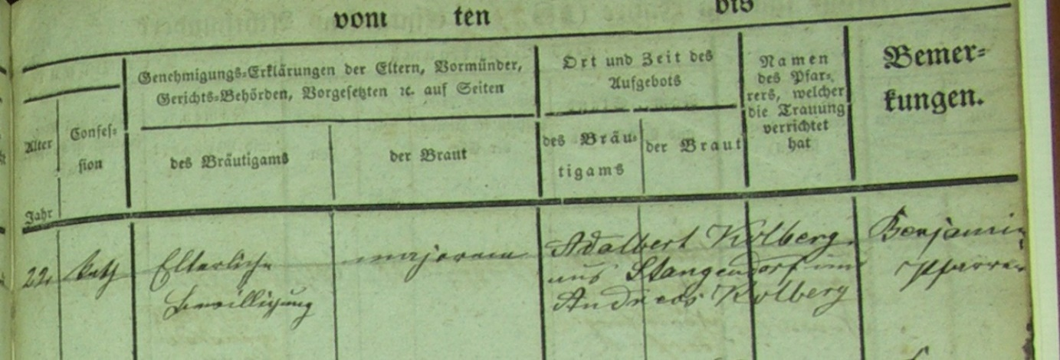
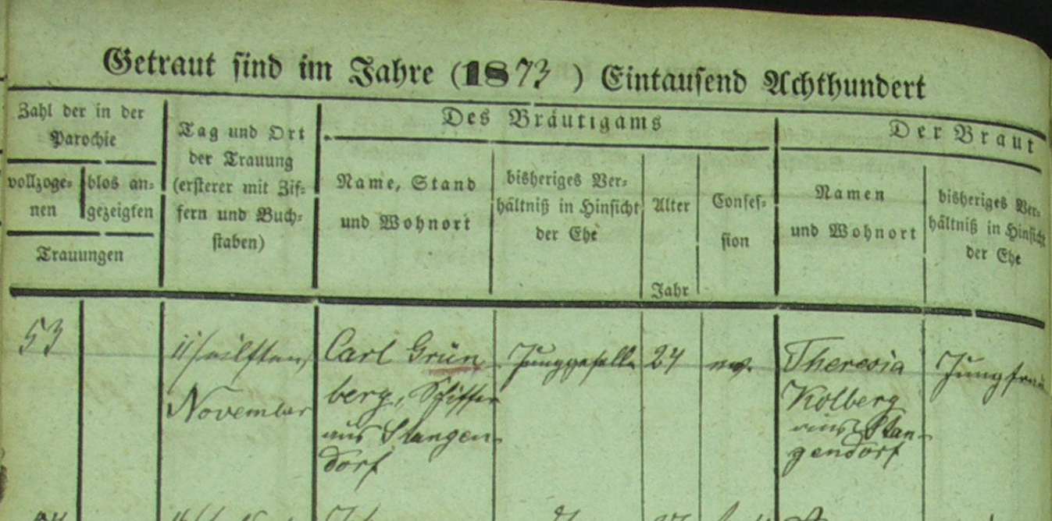
- Teresa Kolberg, aged 22, Catholic, Stangendorf resident.
Unfortunately, it does not their parents’ names..
The witnesses were: Adalbert Kolberg and Andreas Kolberg.

Then I found two of their children:

Franz Albert Grüneberg was born in Glina (German: Stangendorf, Nowe Parish) on June 12th, 1874 to Carl Grünberg and Theresia Kolberg.
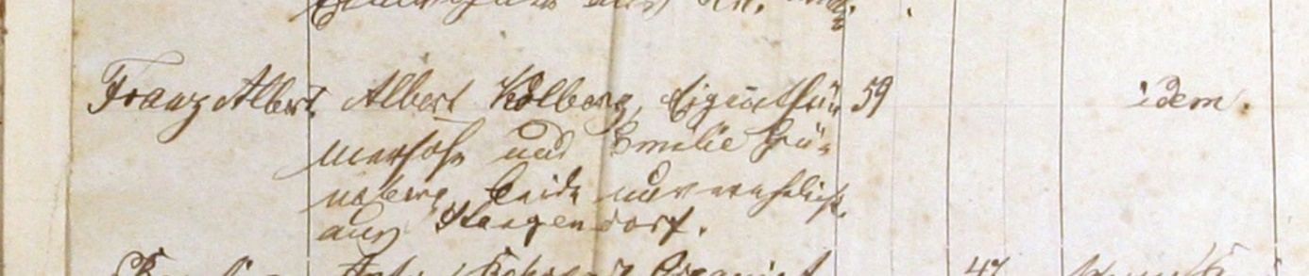
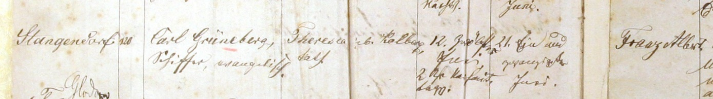
He was baptized on June 21st and his godparents were Albert Kolberg and Emilie Grüneberg.

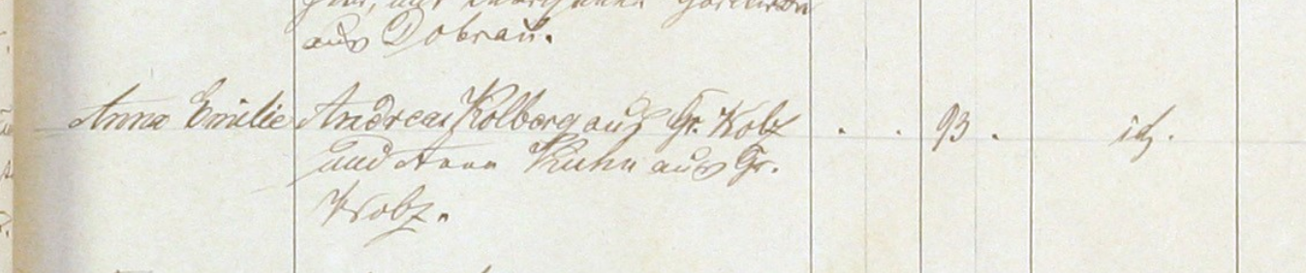
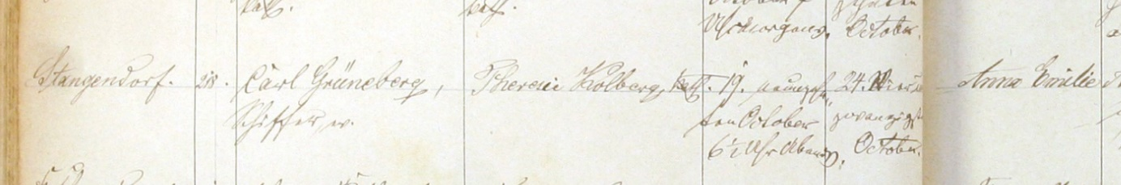
Anne Emilie Grüneberg was born in Glina (German: Stangendorf, Nowe Parish) on October 19th, 1875 to Carl Grünberg and Theresia Kolberg.
She was baptized on October 24th and her godparents were Andreas Kolberg and Anna Kuhn.

Records from Nowe parish are available until 1919. Unfortunately, they do not contain any other entry regarding that family.

I also tried to work on the vital records (starting October 1874) but it’s even more complicated.. Augusta (born in 1879) was registered in the Registry of Vital Records in Gross Nebrau (Nebrowo Wielkie) – that is how the collection of records it titled.

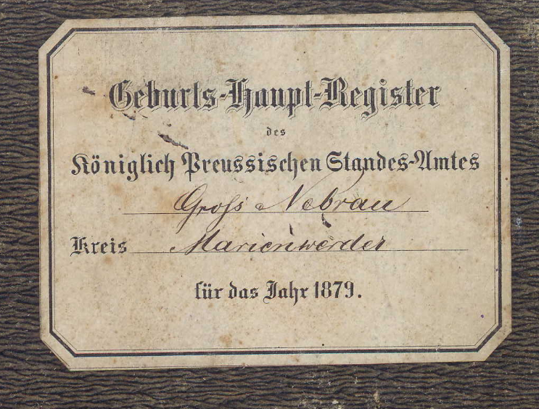

But the header of the record (and all other records in that book) says Klein Nebrau (Nebrowo Małe).
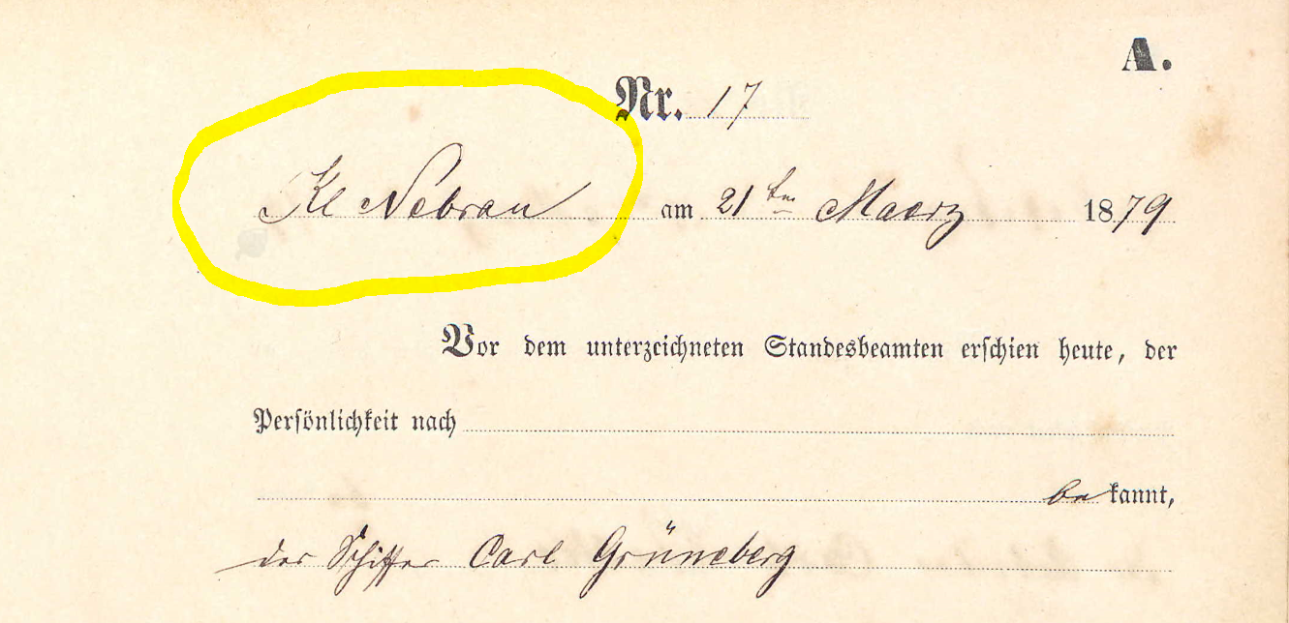
I did not find records from Nebrowo Małe in any of the Polish archives so it might be a mistake, and the only registry was the one in Gross Nebrau.

The Polish archives have only three books from the Registry in Nebrowo Wielkie:
- Births from 1881
- Births from 1882
- Deaths from 1882

More vital records from Gross Nabrau are available in the German archives – but they are also available on ancestry.com
I did not find any other records related to that family in that collection (using the ancestry.com search engine). It is important to mention - many of the books in that collection are missing as well. i.e. from the years 1882-1887 – only the marriage records are available.. It might be also a reason why we cannot find birth records of other children of Karl and Teresa.

I checked not only records from the registry in Nebrau, but went through other registries from the area of Kwidzyn (Marienwerder), where I came across a few other Gruneberg families:

It seems there was one more Karl (Carl) Grüneberg living in that, as I found his daughter’s marriage record:

Auguste Louise Grüneberg, an Evangelic, born on July 17th 1870 in Gross Nebrau, was a daughter of Karl Grüneberg & Elizabeth nee Sadatzki. She got married to Wilhelm Wuhmann in Gross Nebrau in 1897.
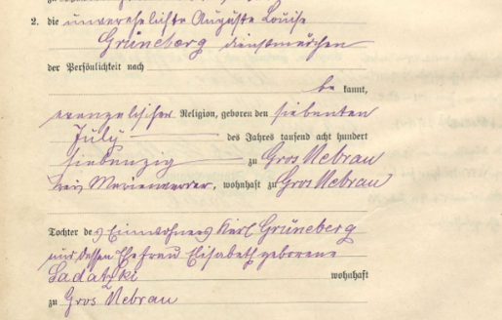

I also found a death record of Karl (Carl) Grüneberg, who died in Karlshof (about 10 miles from Nebrau) in 1926 at the age of 62 (what makes his DOB around 1864).

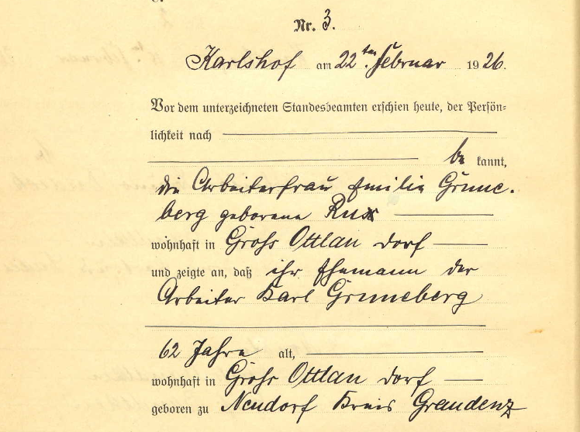

Speaking of ‘your’ Carl Grüneberg – from his marriage record we know that he was born around 1849.
According to one of the databases we use, there was Carl Grüneberg born in Nebrau (Nebrowo) in 1849 – so it might be him.
The only way to prove it would be to compare the exact date of birth of ‘Carl’ listed in a few family trees on ancestry.com with Carl born in the Nabrau parish.

The only document issued in the US saying about Carl born March 9th 1849, that I found is the following:

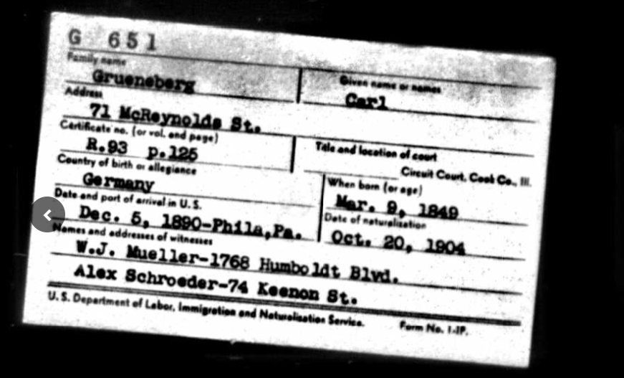
If you are somehow able to confirm that document refers to ‘your’ Carl – than his date of birth is confirmed and we only need to compare it with the Carl born in Nebrau.

While doing the research I read quite a lot about the Glina village, trying to find some information about the origin of the people living there, and came across an interesting information.
The original name of the village, Stangendorf suggests that it could have been founded under the German town law (Deutsches Stadtrecht) by Dietrich Stange, the administrator of the church estates until 1285. Later on, the village was a settlement for the Mennonites who came there either from the Netherlands or Friesland (Polish: Olędrzy). There were also Scottish settlers living in Glina since 1646, they worked mainly as salesmen.

